Flash / ASP Tutorial

This is a simple tutorial to demonstrate how a Flash interface can be incorporated into data driven ASP pages. Because I am a programmer and not a graphics artist you will notice a lack in the graphics department … I’ll leave that up to the experts ☺.

Lets start with the database. In this example we will use a single table in MSAccess, but by just changing the DSN you could in fact use SQLSever or Oracle.
Create a table and name it tblStock.
The fields consist of .

PartNo (Text) (PrimaryKey)
Desc(Text)
Cost(Text)
QtyInStock(Text)

In a real app the Cost & QtyInStock fields would be something other than text, but text is fine for this demonstration.
Add some dummy data.

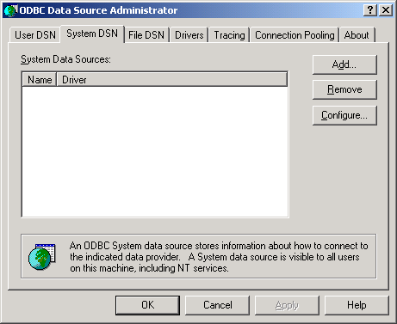
Next create a DSN for our database. Go to Control Panel and select ODBC Data Sources.
Select the “System DSN” tab and click “Add”
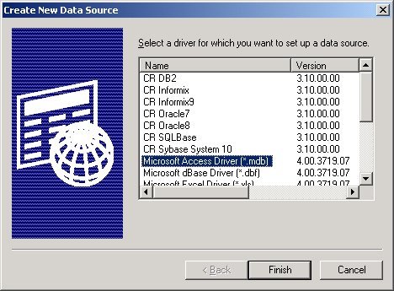
Select the Microsoft Access Driver
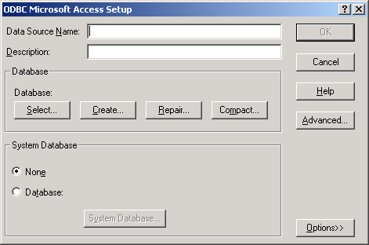
Name the data source StockDSN and click “Select Database”.
Browse to the Stock database we created and click OK. Click OK again and you now have a System DSN for our ASP pages.

That’s it for the database.

In the Flash movie example I have 4 text fields named.
partno, desc, cost, qty.
An Insert button and a clear button.
The Action for the Insert button reads like this
On (Release, Key: <Enter>)
Set Variable: "partno" = partno
Set Variable: "desc" = desc
Set Variable: "cost" = cost
Set Variable: "qty" = qty
Load Variables ("insert.asp", "/", vars=POST)
Go to and Stop ("results")
End On

Note: insert.asp is the page we will create to process the data and Results is the label at the end of the timeline that shows the data has been entered.

You will also need a Stop action at the end of the results frame

The Clear button simply clears the text boxes of any data you entered.

On (Release)
Set Variable: "partno" = ""
Set Variable: "desc" = ""
Set Variable: "cost" = ""
Set Variable: "qty" = ""
End On

Apart from adding some slick scenes that’s all you need on the Flash side.

Now bring up your favorite editor to code our ASP page. I use Netobjects ScriptBuilder.
I find it easy to use and has some nice features. Use whatever you like, you can even use Notepad (Windows)

Before I go on. If you are hosting or testing asp on your machine you will need to make sure IIS or PWS is installed and configured along with ASP itself.

The ASP script looks like this:

<%@ LANGUAGE="VBSCRIPT" %>
<!-- #INCLUDE FILE="adovbs.inc" --> ‘an ado include file, in this example needs to be ‘in the same dir as your asp page

<%
dim part ‘Declare all our variables
dim desc
dim cost
dim qty

part=request.form("partno") ‘Because we used POST in the Flash Action
desc=request.form("desc") ‘we use Request.Form. If GET was used then
cost=request.form("cost") ‘Request.Querystring would be the one to use
qty=request.form("qty")

Set objConn = Server.CreateObject("ADODB.Connection") ‘Create connection
objConn.Open "StockDSN" ‘Our System DSN

Set objRS = Server.CreateObject("ADODB.Recordset") ‘Create recordset object

‘SQL Insert statement goes like this
strSQL = "Insert into tblStock (PartNo, desc, cost, QtyInStock) VALUES ('"
strSQL = strSQL & part & "', '"
strSQL = strSQL & desc & "', '"
strSQL = strSQL & cost & "', '"
strSQL = strSQL & qty & "')"

objconn.execute strSQL ‘Execute the insert query

objRS.Close
Set objRS = Nothing
objConn.Close
Set objConn = Nothing ‘Close and destroy the connection

%>

Save this file as insert.asp
That’s it for ASP

Back in Flash, publish your movie and the HTML file that goes with it.
The ASP page works in the background and is never displayed on the browser.
Ensure all files are in the same dir and relevant permissions are set to access the database.

Run the html and all should work.

Note: There is a lack of error handling in the asp page to inform the user of invalid data or any other errors that might occur. This is just a basic howto to give you the general idea.

The next tutorial will concentrate on searching for a record in our Stock database

